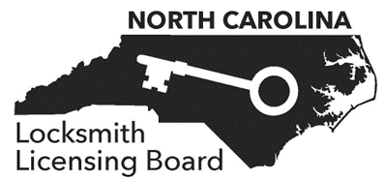



CONSUMER COMPLAINT

Complaints will not be accepted verbally by phone. Please complete the following form and provide as much detail as possible. Some information may not be available, especially if you suspect the locksmith was unlicensed. Please provide telephone numbers, websites, screenshots, photographs, physical descriptions of individuals, etc. If you have general questions regarding the complaint process, please contact the North Carolina Locksmith Licensing Board at [director@nclocksmithboard.org](mailto:director@nclocksmithboard.org).

This Complaint Is Against:

Address:

**City State Zip Code Telephone**

License Number: (A licensee directory can be found on the Board’s website at <https://www.nclocksmithboard.org/verify-license/>)

Your Name:

Address:

**City State Zip Code Telephone**

E-mail Address:

DESCRIPTION OF COMPLAINT

In the space below, tell us about your complaint. Include all the facts that you want the Board to consider, including names, dates, and places. Use additional sheets if necessary. **Attach copies of any documents that support your complaint. Please do not send originals of supporting documents.**

ATTEST

# 

I, the undersigned, hereby submit the above complaint, and attest that it is true and accurate to the best of my recollection. I agree to cooperate by furnishing to the representatives of the Board all pertinent or requested information and records in my possession concerning the alleged misconduct of the person or entity against whom I have complained. I further agree that I will testify as a witness if a hearing is held concerning the alleged misconduct of the person or entity against whom I have complained.

I understand that my identity will be disclosed to the business or person against whom I have complained. I understand that anonymous complaints will not be processed. I understand that, except in limited circumstances, North Carolina public records laws require that copies of complaints and responses be made available to anyone who requests them.

I understand that the Board cannot give me legal advice, cannot represent me or intervene on my behalf in any court proceeding, and cannot provide any opinions or make any determinations regarding civil liability. I understand that if I believe I have suffered damages because of an act or omission of a licensee of the Board, I should not wait for the Board’s disposition of a consumer complaint before pursuing any legal claim or seeking legal advice.

YOUR SIGNATURE

DATE

SUBMIT

**You may mail your complaint to the Board OR you may send it by email.**

**Mail to:** North Carolina Locksmith Licensing Board Attn: Administrative Director

P.O. Box 10972

Raleigh, NC 27605

**E-mail to:** [director@nclocksmithboard.org](mailto:director@nclocksmithboard.org)